Quorum consensus protocol comparison report

Introduction

Quorum is an open-source protocol, that enable Etherum protocol with privacy enable transactions. The below examples are for a Quorum network

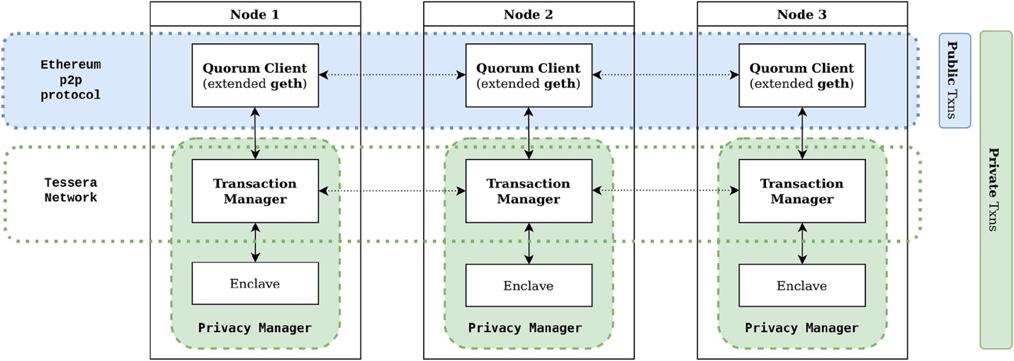

Client comparison

Quorum protocols currently supported by two clients called HyperLedger Besu[1] and Consensys GoQuorum[2].

They support the list of consensus mechanisms
- Ethhash (Proof-Of-Work)
- Istanbul BFT – IBFT (Proof-Of-Authority)
- Clique (Proof-Of-Authority)
- Raft (Proof-Of-Authority)
- Quorum BFT – QBFT (Proof-Of-Authority) (Early access)

At the time of constructing this comparison, GoQuorum have far more forks (~1100) than Besu (~500), the community actively contributed, in

POA Consensus comparison
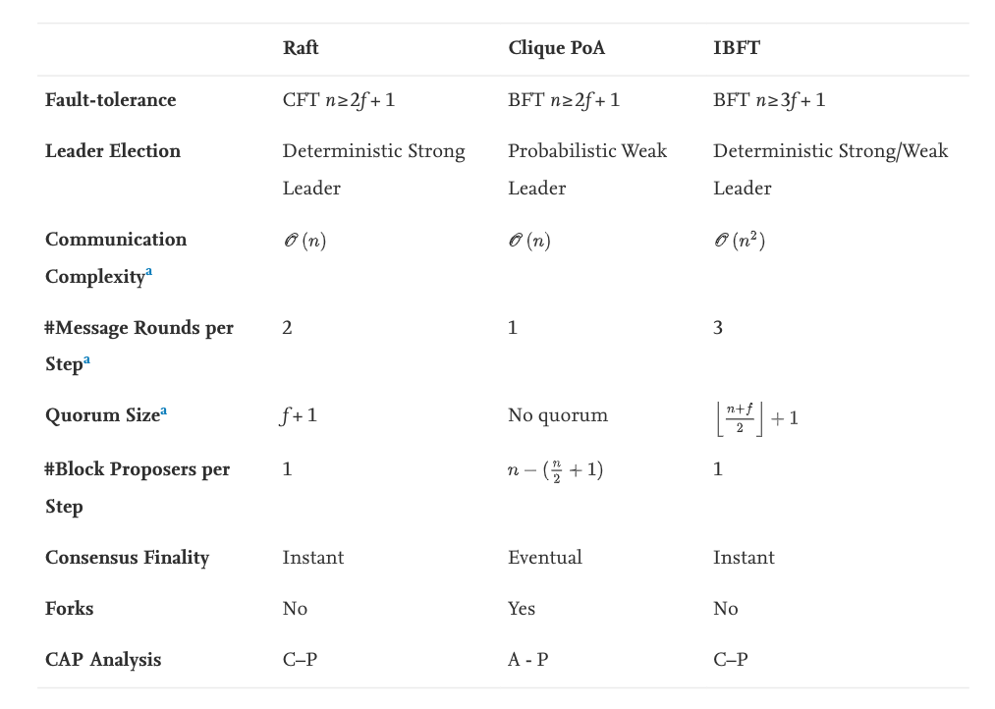

Legend:
N is totals node in the network
F is the number of node considered as faulty nodes

Performance Analysis

For the performance comparison analysis, we refers to an research of [3] about quorum protocol, they used an open source setup forked from HyperLedger Caliper [4]
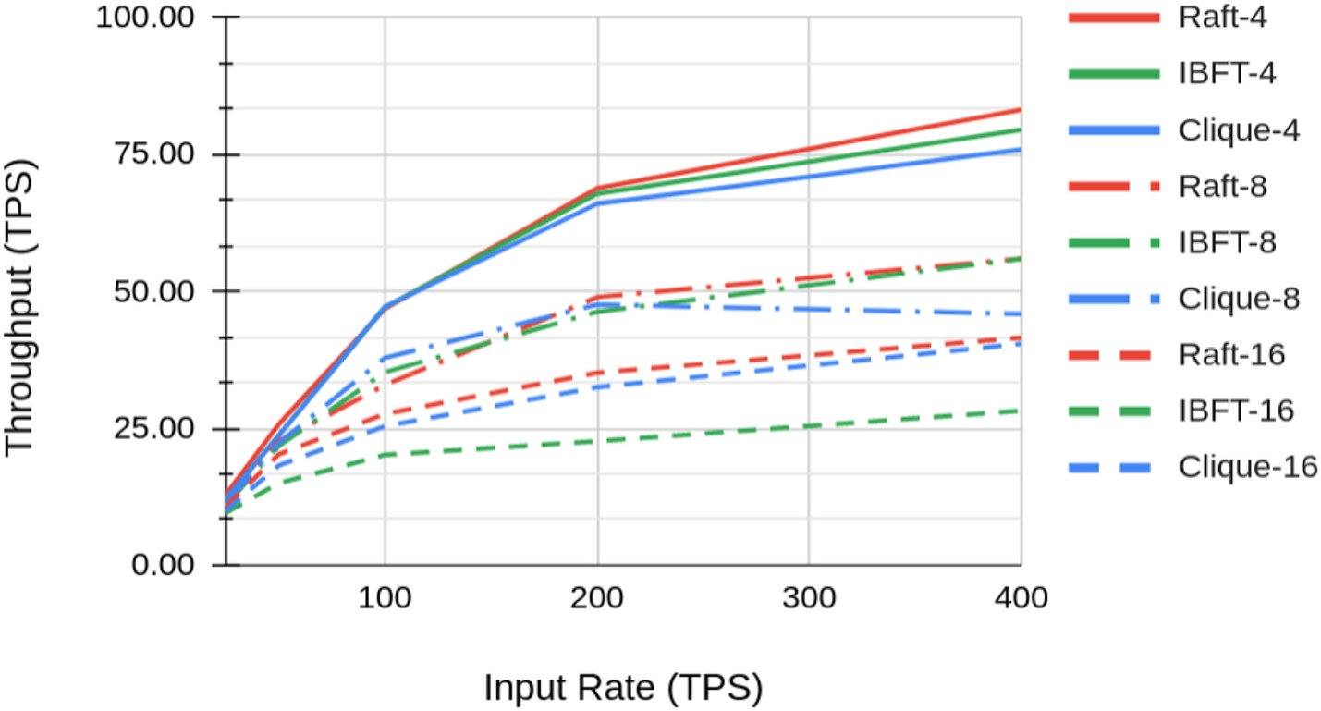

Conclusion

In the case of very limited numbers of nodes, which produces block, using EthHash consensus is vulnerable to different thread models. In this case the attacker, have more than 50% of computing power in the network [5]

It leaves at the options of POA consensus, Raft is not faulty tolerance, as the case of multiple banking partners, so we exclude it, as well as early access QBFT.

Because we need don’t need

Reference
[1] Besu Ethereum Client. Hyperledger, 2022. Accessed: Mar. 04, 2022. [Online]. Available: https://github.com/hyperledger/besu
[2] ConsenSys/quorum. ConsenSys, 2022. Accessed: Mar. 04, 2022. [Online]. Available: https://github.com/ConsenSys/quorum
[3] A. Baliga, I. Subhod, P. Kamat, and S. Chatterjee, “Performance Evaluation of the Quorum Blockchain Platform,” ArXiv180903421 Cs, Jul. 2018, Accessed: Feb. 24, 2022. [Online]. Available: http://arxiv.org/abs/1809.03421
[4] hyperledger/caliper. Hyperledger, 2022. Accessed: Mar. 04, 2022. [Online]. Available: https://github.com/hyperledger/caliper
[5] “Weaknesses - Bitcoin Wiki.” https://en.bitcoin.it/wiki/Weaknesses (accessed Mar. 04, 2022).

